Weapons of Mass Destruction: Rapa Nui *Mata’a* Morphometric Analyses

November 3, 2014

Carl P. Lipo1, Rene Horneman1, Terry L. Hunt2, Vincent Bonhomme3,4

1Department of Anthropology and IIRMES, California State University Long Beach, Long Beach, CA 90840

2Robert D. Clark Honors College, 129 Chapman Hall, 1293 University of Oregon, Eugene, OR 97403-1293 U.S.A

3 School of Mathematics and Statistics, The University of Sheffield, S10 2 TN Sheffield, United-Kingdom.

4UMR 5059 CBAE, Centre de Bio-Archéologie et d'Ecologie, 34000 Montpellier, France.

# Introduction

Rapa Nui (Easter Island, Chile) is a tiny island located in a remote corner of Eastern Polynesia, more than 2000 km from the nearest inhabited body of land (Figure 1). Polynesians first colonized the island when they sailed from central East Polynesia in voyaging canoes during the 13th century AD (Hunt & Lipo 2006; Wilmshurst et al. 2011). Despite the island's diminutive size, remoteness, and limited natural resources, the archaeological record of Rapa Nui is well-known for its nearly 1000 multi-ton statues known as *moai* that once sat atop massive stone platforms known as *ahu* (Hunt & Lipo 2011a).

The dramatic prehistoric investment in monumental architecture stands in marked contrast to the Rapa Nui's environment and historically observed population levels. Even at the first point of European contact, the tiny island was largely devoid of trees and population sizes were just about 3000 individuals (Hunt & Lipo 2011a). While earlier researchers (e.g., Heyerdahl & Ferdon 1965; Heyerdahl 1989) believed the depleted and depauperate state of the island was due to conflict between Polynesians and elite from South America, more recent researchers have interpreted the contrast between the spectacular nature of the archaeological record and the sparse environment of the island as the outcome of a prehistoric environmental catastrophe (Bahn & Flenley 1992; Flenley & Bahn 2003). These researchers argue based largely on oral traditions, that prehistoric populations grew in numbers until resource use exceeded the carrying capacity and the island underwent catastrophic demographic collapse. This account has been popularized as the "collapse" scenario (*sensu* Diamond 1995, 2005).

New research, however, has challenged this notion with empirical evidence generated from the archaeological record that the Rapanui flourished on the island until AD 1722 when Europeans brought diseases and other social disruptions (Hunt 2007; Hunt & Lipo 2007; Hunt & Lipo 2009a; Hunt & Lipo 2009b; Hunt & Lipo 2011a; Hunt & Lipo 2011b; Lipo & Hunt 2009; Mulrooney et al. 2009; Mulrooney 2012; Rainbird 2002). Investigations on Rapa Nui's settlement patterns demonstrate that the island's inhabitants lived in a dispersed pattern in a low-density fashion (Hunt & Lipo 2011a; Morrison 2012). In addition, studies show that subsistence was largely based on extensive but marginally productive lithic mulch gardens to boost the nutrient-poor soil to a level that sustained sweet potato cultivation (Bork et al. 2004; Ladefoged et al. 2005; Ladefoged et al. 2010; Ladefoged et al. 2013; Mieth et al. 2006; Stevenson & Haoa 2002; Stevenson et al. 2006). Finally, demise of the once extensive palm tree forest appears to have had little to do with statue construction or changes in carry capacity (Hunt & Lipo 2011a; Lipo et al. 2013).

One of the claims that persists that is thought to support the "collapse" scenario is the idea that prehistoric Rapa Nui populations experienced intense warfare during late prehistory when resources became increasingly scarce (Bahn & Flenley 1992; Diamond 1995, Diamond (2005); Flenley & Bahn 2003). Oral traditions are known that attribute the toppling of stone statues to intertribal prehistoric warfare (Bahn & Flenley 1992). But the existence of fallen statues alone does not necessarily imply warfare since other natural explanations are more likely (Edwards et al. 1996). Indeed, the existing evidence points to the toppling of statues as series of post-contact historic events rather than prehistory (Hunt & Lipo 2011a). Most significantly, examples of defensive structures are entirely lacking in the island's archaeological record (Hunt & Lipo 2011a; Lipo & Hunt 2014). Overall, much of the evidence for prehistoric warfare among the inhabitants of Rapa Nui comes from oral traditions recorded in the 20th century (e.g., Routledge 1919). The oral traditions, however, have an unknown relation to prehistory. Metraux (1940), for example, argues that most of the traditions are likely recent and thus likely do not reflect prehistoric events. Given the unknown origins of oral traditions, we must rely upon direct archaeological evidence for warfare.

The one example of empirical evidence used to support arguments about prehistoric warfare on Rapa Nui is the presence of *mata’a*, flaked obsidian stemmed tools. *Mata’a* are a class of hafted flaked obsidian artifacts that are found commonly on Rapa Nui. As relatively simple stemmed obsidian tools with wide blades, their form is similar to artifacts found on other Polynesian islands such the basalt and chert tools found on New Zealand, Pitcairn and the Chatham Islands (Balfour 1917; Metraux 1957: 232; Skinner 1958) as well as obsidian examples from New Britain, Papua New Guinea (e.g., Araho 1997; Specht *et al.* 1988; Torrence *et al.* 2009a; Torrence *et al.* 2009b; Torrence et al. 2013).

In the current analysis, we seek to explore whether there exists variability in the shape of *mata’a* that provides information about the functional environment in which these artifacts interacted. Using an image database of 417 *mata’a* from Rapa Nui, we conduct quantitative morphometric analyses, namely outline analysis using elliptical Fourier transforms, to further investigate whether specific tool classes might be identifiable in the range of shapes in which these artifacts are found. Morphometric analyses enable one to explore shape as a continuous property of objects rather than requiring us to treat shapes as nominal categories. Moreover, morphometrics make no assumptions, or a priori, on the shape: it just turns the latter into orthogonal quantitative variables. Moreover In this way we can use multivariate analyses, and particularly ordination approaches including principal components analyses, to see and test if particular kinds of shapes map to particular locations, environments or source material. In addition, we can examine the relative patterns of *mata’a* shape variability and to look for areas of shape that are constrained versus those that are free to vary. Overall, our results conclude that *mata’a* were only functionally constrained in terms of the haft and had significant variation on the distal end and blade. These results continue to support the alternative hypotheses that these artifacts were not used as weapons. The degree of similarity, however, of the haft portion of *mata’a* and the low degree of constraint in the blade poses an intriguing puzzle: we have yet to identify the role(s) that these objects played in Rapa Nui subsistence and settlement.

# Approach

*Mata’a* have been noted since the earliest European visitors described the island. Members of Cook's expedition to the island commented that the islanders “had lances or spears made of thin ill-shaped sticks, and pointed with a sharp triangular piece of black glassy lava” (von Saher 1990: 35). *Mata’a* are often assumed to be "spears" largely because of their resemblance to European varieties rather than any direct observation of their use. Scars noted by early European observers are believed to have been inflicted by *mata’a* though there is no clear evidence that their use was violent or lethal. For example, in his voyage to Rapa Nui in 1770, Captain Don Felipe González (Haedo & Roggeveen 1908:99) remarked that "they [Rapanui] possess no arms, and although in some we observed sundry wounds on the body, which we thought to have been inflicted by cutting instruments of iron or steel, we found that they proceeded from stones, which are their only [weapons of] defence and offence, and as most of these are sharp edged they produce the injury referred to."

Even if we had direct observations of these objects being used in "spear-like" fashion, the unavoidable tendency for these European observers to interpret what they saw through their own preconceptions requires us to examine the physical evidence available on *mata’a*. In this way we can learn not only the range of interactions that the objects had with the environment but also determine if there is *variability* in their use through time or over space.

On the surface landscape of Rapa Nui, *mata’a* are one of the most numerous shaped artifact classes (Figure 2). Overall, *mata’a* vary greatly in size and shape, but average 6-10 cm in width and length. Technologically, they are formed from unifacial flakes derived trough hard hammer percussion on obsidian cores quarried from one of the island's obsidian sources. Most of the shaping of the *mata’a* occurs during the creation of a stem that presumably serves as a haft. The stem is formed from one of the lateral margins of the original flake where blade constitutes the remaining distal and opposite lateral margins. *Mata’a* stems and shoulders are formed by unifacial flaking and are generally lenticular in cross section. Overall, the blade shape is dominated by the shape of the parent flake though some shaping through secondary flaking is sometimes evident. Often, large areas of cortex still cover much of one face.

In exploring the way in which *mata’a* forms vary, researchers have noted that there is a great diversity of shapes that vary from rounded to sub-angular to angular to complex (Mulloy 1961). Early researchers assigned *mata`a* shape variation to what they conceived as ethnographic categories based on Rapanui words (i.e., Routledge 1919). Later attempts to construct systematic classifications have also focused on identifying types based on characterizations of overall shape. None of these classification efforts produced useful categories. Furthermore, none of these shape classification/clustering were assumption-free and they were all driven by strong but latent hypothesis of their use.

Mulloy (1961: 151), for example, argued that “no significant clustering or correlations could be extracted.... the material represents a continuous range of variation without objective natural order, and that the only classification possible must involve the subjective selection of ideal types from infinite series of possibilities, and the arbitrary reference of intermediate forms to one or another of these.” Mulloy concluded manufacturing procedures dictated differences in overall shape of *mata’a* that were best explained by chance.

The overall shape of an object is rarely a useful dimension for problem-oriented classification (Dunnell 1986). The forms of objects are limited by technological constraints of the material, performance aspects that depend upon the range of environments in which the object is used, and simple idiosyncratic variability related to the manufacturer and the process of production. In the case of *mata’a* much of the variability in the overall blade shape can be explained by the contingent results involved in the stages of manufacture (Bollt *et al.* 2006). The difference in shapes, therefore, may have structured functional variation related to the range and kinds of activities for which the tool was primarily used. Studies of use-wear found on *mata’a* point to the tool being used primarily for scraping and cutting or some combination (Church & Rigney 1994; Church & Ellis 1996).

A recent study of *mata’a* shape using stylistic classes and deterministic frequency seriation as a means for examining how class frequencies changed over space and through time showed remarkably continuous change (Lipo *et al.* 2010). The seriation results suggest that the source of variability in *mata’a* form is largely being inherited through the social learning of manufacturing techniques between individuals. The evidence also indicates that variability in the form of *mata’a* is not related to how the *mata’a* performed in its use environment(s). Overall, our growing understanding of *mata’a* variability continues to support their form being related to ceremonial or cultivation activities and not as weapons involved in warfare (Bollt *et al.* 2006; Lipo *et al.* 2010).

In our analysis here, we focus on *mata’a* variability in the blade portion of the *mata’a* relative to the stem. We assume that as hafted objects the point at the center of the stem where it meets the blade can be held constant for comparisons of shape. We then assume that due to performance the functional aspects of the tool will result in shape variability that is more constrained than the non-functional or stylistic attributes (Lipo et al. 2012). The constraints are the result of natural selection that serves to sort shape variability in proportion to the benefits/drawbacks to performance. Based on this notion, we hypothesize that:

* If *mata’a* are weapons, the distal end of the artifact will be constrained. However, if *mata’a* are not weapons, other areas of the tool will show greater constraint consistent with alternate functions.
* If *mata’a* are weapons, the distal end of the artifact will show a tendency towards a consistently shaped pointed spear-like shape that will penetrate either enemies or prey. If *mata’a* are not weapons, there will be no such constrictive tendency at the distal end of the tool.

# Methods and Data

In order to test these hypotheses, we used modern morphometrics. Morphometrics is the quantitative analysis of form in terms of shape and size, in two or more dimensions (Bookstein 1982; Bookstein *et al.* 1985; Bookstein 1997; Cardillo 2010; Kendall 1989; Rohlf 1990). Both approaches have huge advantages over traditional studies of shape using global shape descriptors, or lengths and ratios of lengths. First, modern morphometrics avoid the problem of nominal shape (e.g., "triangular", "square", "round") by transforming the overall shape into independent, quantitative variables. Then, with techniques available for standardizing position, scale and rotation, morphometrics allow to explore, compare and test for differences in the shape (form minus size) of artifacts. Additionally, a single set of coefficients correspond to a single shape (where very different shapes can have the same eccentricity, ratios of lengths, etc.). Last but not least, modern morphometrics are information-preserving: shapes can be reconstructed/averaged/extrapolated/etc. using their morphometric coefficients.

Modern morphometrics consider the overall geometry of the shape and can be obtained in a number of ways. With roots in biology, the earliest form of morphometrics focused on identifying the location specific landmarks (e.g., Thompson 1917). A landmark approach requires defining features of interest that are to be examined as to how they relate to each other. In the case of artifacts such as *mata’a* there are few consistent landmarks to hold constant other than perhaps the distal and proximal end. One can also conduct an analysis of what is known as "semi-landmarks," a fixed number of regularly positioned points around the outline of an object (Bookstein 1997; Gunz & Mitteroecker 2013). Both approaches to measuring shape make use of the relative positions between all points (Bookstein 1991; 1997). When landmarks are absent, too few, or not consistent among shapes we use the entire geometry of the outline of the shapes, when projected on a plane (ie top, lateral, polar views). Mata’a shapes clearly fall on the second case, and we used outline analysis with elliptical Fourier transforms.

In our morphometric analyses we make use of *Momocs* v0.99 (<http://CRAN.R-project.org/package=Momocs>), an R package (R Core Team 2014) developed by Bonhomme (2012; Bonhomme et al. 2014), that implement modern morphometrics and notably outline analysis using elliptical Fourier transforms, described extensively elsewhere (Kuhl & Giardina, 1982; Giadina & Kuhl 1977) For our analyses of Rapa Nui *mata’a*, our assemblage consisted of planview photographs artifacts from two museum collections. Outlines of the studied *mata’a* are shown in Figure 3). The first museum collection consisted of 118 *mata’a* housed at the P. Sebastian Englert Museum on Rapa Nui. This collection is composed of photographs of *mata’a* collected from 4 locations on the island as well as 299 *mata’a* for which provenience is known only to the level of the island itself (Figure 3).

The second collection of *mata’a* is composed of 291 objects housed at the Bishop Museum, Honolulu, Hawai'i. These *mata’a* consist of examples purchased from the island by a private collector in 1920, collections made by Kenneth P. Emory in 1929-1931 and various gifts to the museum (Mulrooney et al. 2014: 5–6). Mulrooney and colleagues took photos of these *mata’a* during their study of obsidian sourcing via pXRF (Mulrooney et al. 2014). Their findings demonstrate that the majority of *mata’a* were made from obsidian obtained at the Orito source, though some examples are made from obsidian from the Rano Kao and offshore Motu Iti sources. Due to the manner in which the Bishop Museum material was originally collected, we can only attribute the source of these *mata’a* to Rapa Nui and not a specific location on the island. Despite this limitation, we are able to use these *mata’a* examples to examine potential shape variability that might be due to the obsidian source. This shape variability could be potentially caused by systematic material differences or by the differential use of *mata’a* that are derived from different locations.

Together these two collections provide 417 image of *mata’a*. Based on bootstrap estimates of basic metrics (Figure S1), this sample size appears to be large enough to adequate characterize shape and overall *mata’a* configuration.

For the purposes of our analyses and following the approach taken in Lipo et al. (2010), we assumed that *mata’a* are the hafted portions of compound tools that are otherwise incompletely preserved in archaeological deposits. In this context and based on evidence of use wear on the distal edges (Church & Rigney 1994; Church & Ellis 1996), we assume that the overall *mata’a* shape is a functional element (*sensu* Dunnell 1978), the portion of the artifact that interacts with the environment. Consequently, our interest is on those aspects of shape that potentially affect function and thereby come under natural selection. The task of explaining variability in shape consists of identifying selective pressures that affect the performance of shape and to determine whether their magnitude is sufficiently great to impact fitness. The greater the selective pressures on performance, the more constraint we would expect on those aspects of shape. If the effect on function and performance is sufficiently small, then other forces such as technological (i.e., material source, manufacturing steps, etc.) or stylistic (stochastic or neutral) ones may have played a role in fixing the shapes of *mata’a*, as well as when and where they occur in the archaeological record. In these cases, we would expect to see a greater range of variability. It is possible, however, that not all *mata’a* instances were used in the same way. If *mata’a* shape is influenced by more than one function, either contemporaneously or over time, then the selective context will differ and thus the “cause” of *mata’a* shape should vary. In this scenario we would expect to see modal patterns of *mata’a* shape where outline variants form statistically-distinguishable groups.

## Outline Data

In our analyses, we aligned scaled photos of *mata’a* at the point where the midpoint of the stem meets the blade. We oriented each image with the centerline of the haft. These steps helped insure that the shapes were directly comparable. We converted the images to binary to isolate the artifact from the background and then used TPSDig software (Rohlf 2014) to create outlines of each *mata’a*. TPSDig was particularly useful as it provides a means for automatically tracing outlines with a fixed number of points. In the creation of outlines, we identified 200 sets of X-Y coordinates located on equidistant points along the perimeter of the artifact (Figure 4). The set of coordinates for each *mata’a* were aggregated into a single file using PAST (Hammer et al. 2001). Finally, we standardized the outlines for differences in sizes by dividing the coordinate positions by the total length of each outline (Figure S2).

Simple metrics of length and width (Figure 5) suggest that there is just a single distribution of these objects without clear-cut modes in size. Comparisons of length and width, however, are fairly crude descriptions of shape. A more direct means of evaluating shape variability is accomplished by superimposing *mata’a* outlines (Figure 6). This process required selecting a standard reference point for all objects from which measurements would be based. We selected our reference points, referred to here as “centroids,” based on the points from which we believe variability will be meaningfully constrained (or not). In this case of *mata’a*, we chose a centroid at the center of the haft where it intersects the blade.

Once we identified the centroid, we calculated the distance from the centroids to the perimeter in one-degree intervals for the 360-degree perimeter. One-degree increments provide sufficient detail about shape at a scale that characterized overall shape variability with enough detail to capture attributes regarding the haft shape and distal blade shape outline.

For example, as shown in Figure 7, we can use the digitized outlines to show where the distance from the centroid varies and where it is more constrained. By calculating the 95% confidence intervals for all of the radial distance, we can see that the *mata’a* shape varies the least at the point where the stem intersects the blade. The stem length, however, varies as does the overall distal blade edge. This finding suggests that the most important part of the shape of the mata’a is its ability to be hafted: the rest of the shape is not strongly constrained.2

# Morphometric Analyses: Elliptic Fourier Analysis

With morphometrics, we can go further and exam the degree to which shape variability may form groups that are related to specific functions. In this effort, Fourier based analyses are powerful tools for the study of shape variability (Claude 2008, Bonhomme 2014). Fourier approaches treat shape into a periodic function that can be fitted using a sum of simple trigonometric functions such as sine and cosine. These simple functions are frequencies that are integer multiples, i.e. are harmonics, of one another. Lower harmonics provide approximation for the coarse-scale trends in the original periodic function while the high-frequency harmonics fit its fine-scale variations3 (Figure 8). Coefficients, or amplitude of every trigonometric functions, are used as quantitative variables.

Based on the elliptical Fourier characterizations of the *mata’a* we can now examine the shapes to determine if there are clusters of shape classes that might distinguish different functional sub-groups from each other. Figure 9 presents the position of *mata’a* shapes on a factorial map with shapes reconstructed from the first two principal component axes (gathering 45% of the total variance). Based on these data we do not have discrete shape groups: *mata’a* are highly variable in outline shape and there are continuous intermediate shapes between all variants. The proximal haft end of the *mata’a* is free to vary in shape and the distal end is free to vary in length. These results fail to indicate any subgroup that might have been specifically built as lethal weapons and supports the notion that *mata’a* have no particular function for which blade shape affects performance. Given observations of use-wear on the blade edges (e.g., Church 1998; Church & Rigney 1994; Church & Ellis 1996; Stevenson & Cardinali 2008: 107), it is likely that this means that *mata’a* simply must have an edge sufficient for cutting and scraping.

We can also examine the *mata’a* to see if there are systematic differences between the locations from which *mata’a* are found or between the obsidian sources used to make the artifacts. In our analyses, we have examples of *mata’a* from 4 sites on Rapa Nui (Table S1 and S2). Figure 10 presents the distribution of sets of *mata’a* from multiple locations across the island. The graph includes the 50% gaussian confidence ellipses for each of the 4 sites and the underlying grid represents the morphological space based on the first two principal components. The overlap of the groups indicates that the shapes from each of the sites cannot be distinguished. The same conclusion can be drawn from the analysis of the shape variability relative to obsidian source (Figure 11). Overall, there appears to be no evidence that *mata’a* blade shape was constrained due to functional performance. (MANOVA + MANOVA_PW)

# Comparison with stemmed tools from other Pacific Islands

The *mata’a* of Rapa Nui share some similarity with stone tools found on other islands across the Pacific. On New Britain in Melanesia, for example, Torrence (2009a, 2009b, 2013) has described obsidian stemmed tools that share much in common with the shape of *mata’a*. Torrence (see also Kononenko 2012) argues that these tools may have been used for a range of activities including tattooing and ritual scarification. An additional but limited comparison can be made with Pitcairn Island, where a few stemmed lithic tools have been found (Heyerdahl & Ferdon 1965). Pitcairn Island is a remote Eastern Polynesian island that is located ca. 1900 km to the west of Rapa Nui. Historically related Polynesian populations inhabited the island, though it was later abandoned during prehistory. Stemmed lithics of chert known as locally as "mataa" are also found on the Chatham Islands and on New Zealand (Jones 1981).

As a comparison for our study, we generated outlines of examples of stemmed lithic tools from published images and drawings of these islands using the same procedure as for Rapa Nui (Table S3). Our elliptic Fourier analyses of shape variability required 13 harmonics to adequately characterize the shape of all of the stemmed artifacts (Figure 12). While the sample sizes of the non-Rapa Nui assemblages are small, when we compare the shapes of Rapa Nui *mata’a* with those other objects, we find that the Pitcairn Island stemmed artifacts have overall shapes that are quite distinct. While we cannot rule out the possibility that the Pitcairn examples are a few extremely long and pointed shapes that happen to have been collected from a much wider array of variability, these shapes are certainly more consistent with hafted tools for hunting or weapons. New Zealand “mataa” are similar but have substantially thicker stems than the Rapa Nui artifacts. Jones (1981) suggests that this might reflect tools that are hafted with the edge perpendicular to the shaft like an adze. Given their chert composition and relatively steep edge angles, this shape might be well suited for woodworking.

The New Britain artifacts, on the other hand, show a wide array of features that are more like the ones from Rapa Nui. Based on this comparison, it is certainly conceivable that one of the Rapa Nui *mata’a* functions reflect the same kinds of uses that are thought to characterize the New Britain tools. Tattooing is known from Rapa Nui through ethno-historic observation (Huish 1839: 77; Métraux 1940; Thomson 1891: 22) and as markings on the prehistoric moai (Lee 1992). It would not be surprising that at least some of the *mata’a* objects were used in tattooing and scarification practices, though their numbers and widespread distribution suggests that they were likely not all used in this fashion.

# Conclusion

Our investigation of shape variability for Rapa Nui *mata’a* fails to support our initial hypotheses about the potential use of these objects as weapons. While the notion that Rapa Nui prehistory consists of a tale of collapse and self-destruction remains popular, the evidence to support this claim is non-existent. In addition to a lack of defensive structures and skeletal evidence of lethal violence (Hunt & Lipo 2011a), from the so-called "weapons of mass destruction" (Keegan 1993) when we take a careful look at the shape of *mata’a* we simply do not see evidence that these classes of artifacts represent lethal weapons (see also Ingersoll & Ingersoll 2013). There appears to be no performance requirements that would influence the blade shape. Other than having a sharp edge, *mata’a* are no more lethal than throwing any other kind of rock. Indeed, as documented in post-contact Rapa Nui, rock throwing from high points is the primary way in which native Rapanui fought off the intrusion of Europeans, (e.g., Roggeveen's 1722 visit, Eyzaguirre et. al 1908).

That *mata’a* had more than one function is not surprising since it is essential to resist the notion that any object is imbibed with an inherent function (Dunnell 1978). Instead, we measure function on the empirical variability for any assemblage of objects (Dunnell *et al.* 1976). In the case of *mata’a* the wear patterns and distribution in rock mulch suggest that at least some of these objects were employed in cultivation. We also cannot rule out that they were used in tattooing and scarification practices. The latter function certainly is consistent with observations of healed scars made by Spanish visitors in AD 1770 (Eyzaguirre *et al.* 1908).

It is unfortunate that in the case of Rapa Nui, the myth of the island continues to persist despite the lack of evidence. Tradition has long trumped empirical inquiry when it comes to understanding the functional role that *mata’a* played within the subsistence and social dimensions of prehistoric Rapa Nui. In the case of Rapa Nui, getting the correct answer is far from a trivial academic exercise. The island's prehistory is often used as an exemplar of ignoring the impacts humans make on the environment and thus is driving policy decisions. United Kingdom Prime Minister Margaret Thatcher, for example, famously used Rapa Nui as a warning in a 1989 presentation to the General Assembly of United Nations (e.g., Thatcher 2014). Similarly, *Mata’a* have been used as examples of mass effect "weapons" in a study of terrorist tactics (Rasmussen & Hafez 2010). Given the contemporary importance that Rapa Nui has in guiding our concerns for our future, we owe it to ourselves to make certain that we fully understand the prehistory of the island and that our understanding is based on well documented evidence.

# ACKNOWLEDGEMENTS

The authors would like to thank Francisco Torres Hochstetter, Director of the P. Sebastian Englert Museum, Hanga Roa, Isla de Pascua, Chile for kindly assisting us with this work. We would also like to thank Mara Mulrooney for sharing her compositional data for the Bishop Museum *mata’a.* Thanks are also due to Joanne Minerbi for her work in preparing the images. Rene Horneman was supported for this project through an undergrad research assistant program offered by the CSULB Office of Research and Sponsored Programs.

# References Cited

Araho, N. 1997. Obsidian stemmed tools from west New Britain, Papua New Guinea. Unpublished Masters of Philosophy Disertation, University of Sydney, Sydney.

Bahn, P. & J. Flenley 1992. *Easter Island, Earth Island.* Thames, London.

Balfour, H. 1917. Some ethnological suggestions in regard to Easter Island, or Rapanui. *Folklore* 28: 356–81.

Bollt, R., J.E. Clark, P.R. Fisher & H.K. Yoshida 2006. An experiment in the replication and classification of Easter Island *mata’a.* *Rapa Nui Journal* 20: 125–33.

Bonhomme, V. 2012. *A graphical introduction to Momocs and outline analysis using R.* <http://www.vincentbonhomme.fr/Momocs/vignettes/>.

Bonhomme, V., S. Picq, C. Gaucherel & J. Claude 2014. Momocs: Outline analysis using R. *Journal of Statistical Software* 56: 1–24.

Bookstein, F.L. 1982. Foundations of morphometrics. *Annual Review of Ecology and Systematics* 13: 451–70. [http://www.filogenetica.org/cursos/deluna/morfometria/referencias en pdf/Bookstein82.pdf](http://www.filogenetica.org/cursos/deluna/morfometria/referencias%20en%20pdf/Bookstein82.pdf).

— 1991. *Morphometrics tools for landmarks data*. Cambridge University Press, New York.

— 1997. Landmark methods for forms without landmarks: Morphometrics of group differences in outline shape. *Medical Image Analysis* 1: 225–43. <http://femininebeauty.info/i/bookstein.sliding.pdf>.

Bookstein, F.L., B. Chernoff, R.L. Elder, J. Humphries, G.R. Smith & R.E. Strauss 1985. *Morphometrics in evolutionary biology: The geometry of size and shape change, with examples from fishes.* Academy of Natural Sciences of Philadelphia, Philadelphia.

Bork, H.R., A. Mieth & B. Tschochner. 2004. Nothing but stones? A review of the extent and technical efforts of prehistoric stone mulching on Rapa Nui. *Rapa Nui Journal* 18: 10–14.

Bowman, A. 2009. Review of ’Morphometrics with R.’ *Journal of Statistical Software* 31: 1–2.

Cardillo, M. 2010. Some applications of geometric morphometrics to archaeology, in A. Elewa (ed.) *Morphometrics for non-Morphometricians*: 325–41. Springer-Verlag, New York.

Church, F. 1998. Upland, lowland, citizen, chief: Patterns of use-wear from five Easter Island sites, in G.L. Christopher M. Stevenson & F.J. Morin (ed.) *Easter island in Pacific Context South Seas Symposium: Proceedings of the fourth international conference on Easter Island and East Polynesia*: 312–15. Easter Island Foundation, Los Osos, CA.

Church, F. & G. Ellis. 1996. A use-wear analysis of obsidian tools from an Ana Kionga. *Rapa Nui Journal* 10: 81–88.

Church, F. & J. Rigney 1994. A microwear analysis of tools from site 10-241, Easter Island–An inland processing site. *Rapa Nui Journal* 8: 101–5.

Claude, J. 2008. *Morphometrics with R*. Springer, New York.

Diamond, J. 1995. Easter’s end. *Discover* 9: 62–69.

— 2005. *Collapse: How societies choose to fail or succeed*. Viking, New York.

Dunnell, R.C. 1978. Style and function: A fundamental dichotomy*. American Antiquity* 43: 192–202.

— 1986. Methodological issues in Americanist artifact classification. *Advances in* *Archaeological Method and Theory* 9: 149–207.

Dunnell, R.C., D.E. Lewarch & S.K. Campbell 1976. Test excavations at the Hamilton Island Site, 45-SA-12. Seattle: Dept. of Anthropology, University of Washington.

Edwards, E., R. Marchetti, L. Dominichetti & O. Gonzales-Ferran 1996. When the earth trembled, the statues fell. *Rapa Nui Journal* 10: 1–15.

Eyzaguirre, E.R.-T. (ed.) 2004. *Easter Island: The first three expeditions*. Easter Island: Rapanui Press.

Flenley, J. & P.G. Bahn 2003. The enigmas of Easter Island: Island on the edge. New York: Oxford University Press.

Giardina, C. R. and F. P. Kuhl 1977. Accuracy of curve approximation by harmonically related vectors with elliptical loci. *Computer Graphics and Image Processing* 6(3):277-285

Gunz, P. & P. Mitteroecker 2013. Semilandmarks: A method for quantifying curves and surfaces. *Hystrix, the Italian Journal of Mammology* 24: 103–9. <http://www.italian-journal-of-mammalogy.it/article/download/6292/pdf_6292>.

Haedo, F.G. de. & J. Roggeveen. 1908. The voyage of captain don Felipe González: In the ship of the line San Lorenzo, with the frigate Santa Rosalia in company, to Easter Island in 1770-1. Cambridge: Hakluyt society.

Hammer, Ø., D.A.T Harper & P. D. Ryan 2001. PAST: Paleontological statistics software package for education and data analysis*. Palaeontologia Electronica* 4: 1–9.

Heyerdahl, T. 1989. *Easter island–the mystery solved*. London: Souvenir Press.

Heyerdahl, T. & E. Ferdon. 1965. Reports of the Norwegian archaeological expedition to Easter Island and the East Pacific. Vol. 2. London: Allen, Unwin.

Huish, R. 1839. A narrative of the voyages and travels of Captain Beechey, to the pacific and Behring’s straits; performed in the years 1825, 26, 27 and 28. For the purpose of co-operating with the expeditions under Captains Parry and Pranklin. and of Captain Back, R.N., to the Thlew-ee-choh river & the arctic sea, in search of the expedition under Capt. J. Ross, R.N., being the conclusion of the series of voyages instituted for the discovery of the North West Passage. W. Wright, Southwark.

Hunt, T.L. 2007. Rethinking Easter Island’s ecological catastrophe*. Journal of Archaeological Science* 34: 485–502.

Hunt, T.L. & C.P. Lipo. 2006. Late colonization of Easter island. *Science* 311: 1603–6.

Hunt, T.L. & C.P. Lipo. 2007. Chronology, deforestation, and ‘collapse:’ evidence vs. faith in Rapa Nui prehistory. *Rapa Nui Journal* 21: 85–97.

— 2009a. Revisiting Rapa Nui (Easter Island) ‘ecocide.’ *Pacific Science* 63: 601–16.

— 2009b. Ecological catastrophe, collapse, and the myth of `ecocide’ on Rapa Nui (Easter Island), in P.A. McAnany & N. Yoffee (ed.) *Questioning collapse: Human resilience, ecological vulnerability, and the aftermath of empire*: 21–44. New York: Cambridge University Press.

— 2011a. Easter Island’s complex history. *Nature* 479: 41.

Hunt, T.L. & C.P. Lipo. 2011b. *The statues that walked*. New York: Simon & Schuster.

Ingersoll, D.W. & K.B. Ingersoll. 2013. Art of distraction: Rocking the farm, in B.D. Lundy (ed.) *The art of anthropology / the anthropology of art*: 23–64. Knoxville, Newfound Press.

Jones, K. 1981. New Zealand mataa from Marlborough, Nelson and the Chatham islands. *New Zealand Journal of Archaeology* 3: 89–107.

Keegan, J. 1993. *A history of warfare*. Vintage Books, New York.

Kendall, D. 1989. A survey of the statistical theory of shape. *Statistical Science* 4: 8–120.

Kononenko, N. 2012. Middle and late Holocene skin-working tools in Melanesia: Tattooing and scarification? *Archaeology in Oceania* 47: 14–28.

Kuhl, F. F. P., and C. C. R. Giardina 1977. Elliptic Fourier features of a closed contour. *Computer Graphics and Image Processing. 13(3): 236-258.*

Ladefoged, T., C. Stevenson, P. Vitousek & O. Chadwick 2005. Soil nutrient depletion and the collapse of Rapa Nui society. *Rapa Nui Journal* 19: 100–105.

Ladefoged, T.N., A. Flaws & C.M. Stevenson. 2013. The distribution of rock gardens on Rapa Nui (Easter Island) as determined from satellite imagery*. Journal of Archaeological Science* 40: 1203–12.

Ladefoged, T.N., C.M. Stevenson, S. Haoa, M. Mulrooney, C. Puleston, P.M. Vitousek. & O.A. Chadwick. 2010. Soil nutrient analysis of Rapa Nui gardening. *Archaeology in Oceania* 45: 80–85.

Lee, G. 1992. *Rock art of Easter Island: Symbols of power, prayers to the gods*. Institute of Archaeology, University of California, Los Angeles.

Lipo, C.P. & T.L. Hunt 2009. AD 1680 and Rapa Nui prehistory. *Asian Perspectives* 48: 309–17.

Lipo, C.P. & T.L. Hunt 2014. Easter Island, archaeological evidence, and the evolutionary history of warfare. Paper presented at the 79th Annual Society for American Archaeology meetings. Austin, TX.

Lipo, C.P., T.D. Hunt & R.C. Dunnell. 2012. Formal analyses and functional accounts of groundstone ‘plummets’ from Poverty Point, Louisiana. *Journal of Archaeological Science* 39: 84–91.

Lipo, C.P., T.L. Hunt & S.R. Haoa 2013. The ’walking’ megalithic statues (*moai*) of Easter Island. *Journal of Archaeological Science* 40: 2859–66.

Lipo, C.P., T.L. Hunt & B. Hundtoft 2010. Stylistic variability of stemmed obsidian tools (*mata’a*), frequency seriation, and the scale of social interaction on Rapa Nui (Easter Island). *Journal of Archaeological Science* 37: 2551–61.

Metraux, A. 1957. *Easter Island: A stone-age civilization of the Pacific*. Oxford University Press.

Métraux, A. 1940. Ethnology of Easter Island. Bishop Museum Press, Honolulu.

Mieth, A. H. Bork, J. McNeill & V. Winiwarter 2006. The dynamics of soil, landscape and culture on Easter Island (Chile). White Horse Press., Isle of Harris, UK.

Morrison, A. 2012. An archaeological analysis of Rapa Nui settlement structure: A multi-scalar approach. PhD disertation, Department of Anthropology, University of Hawai’i, Manoa.

Mulloy, W. 1961. Ceremonial center of Vinapu, in T. Heyerdahl & E. Ferdon (ed.) *The archaeology of Easter Island*: 93–180. 24. Monograph of the School for American Research, the Kon Tiki Museum.

Mulrooney, M. 2012. Continuity or collapse? Diachronic settlement and land use in Hanga Ho`onu, Rapa Nui (Easter Island). PhD dissertation, Department of Anthropology, University of Auckland.

Mulrooney, M., T.N. Ladefoged, C.M. Stevenson & S. Haoa 2009. The myth of AD 1680: New evidence from Hanga Ho’Onu, Rapa Nui (Easter Island). *Rapa Nui Journal* 23: 94–105.

Mulrooney, M.A., A. McAlister, C.M. Stevenson, A.E. Morrison & L. Gendreau. In press. Sourcing Rapa Nui *mata`a* from the collections of Bishop Museum using non-destructive pXRF. *Journal of the Polynesian Society.*

Rainbird, P. 2002. A message for our future? The Rapa Nui (Easter Island) ecodisaster and pacific island environments. *World Archaeology* 33: 436–51.

Rasmussen, M.J. & M.M. Hafez 2010. Terrorist innovations in weapons of mass effect: Preconditions, causes and predictive indicators. Workshop Report. The Defense Thread Reduction Agency, Advanced Systems, Concepts Office, Washington, D.C.

Rohlf, F.J. 1990. Morphometrics. *Annual Review of Ecology and Systematics* 21: 299–316.

— 2014. *TPS software*. <http://life.bio.sunysb.edu/ee/rohlf/software.html>.

Routledge, K. 1919. *The Mystery of Easter Island: The Story of an Expedition*. Sifton, Praed, London.

Skinner, H.D. 1958. Some recent publications relating to Easter Island culture and its probable history. *The Journal of the Polynesian Society* 67: 248–51.

Specht, J., R. Fullagar, R. Torrence & N. Baker 1988. Prehistoric obsidian exchange on Melanesia: A perspective from the Talasea sources. *Australian Archaeology*, 3–16.

Stevenson, C.M. & S.H. Cardinali. 2008. *Prehistoric Rapa Nui: Landscape and settlement archaeology at Hanga Ho’Onu*. Easter Island Foundation, Los Osos, CA.

Stevenson, C.M., T.L. Jackson, A. Mieth, H.-R. Bork & T.N. Ladefoged 2006. Prehistoric and early historic agriculture at Maunga Orito, Easter Island (Rapa Nui), Chile, *Antiquity* 80: 919–36.

Stevenson, C.M., T. Ladefoged & S. Haoa 2002. Productive strategies in an uncertain environment: prehistoric agriculture on Easter Island*. Rapa Nui Journal* 16(1):17-22.

Thatcher, M. 2014. Speech by Margaret Thatcher to United Nations General Assembly (Global Environment) 11/8/1989. <http://www.unep.org/Documents.Multilingual/Default.asp?DocumentID=2712&ArticleID=9462&l=en>.

Thompson, D.W. 1917. *On growth and form*. Cambridge University Press, Cambridge.

Thomson, W.J. 1891. *Te pito te henua; or, Easter Island*. Government Printing Office, Washington.

Torrence, R., S. Kelloway. & P. White. 2013. Stemmed tools, social interaction, and voyaging in early–mid Holocene Papua New Guinea. *The Journal of Island and Coastal Archaeology* 8: 278–310.

Torrence, R., P. Swadling, W. Ambrose, N. Kononenko, P. Rath & M. Glascock 2009. Obsidian stemmed tools and mid-Holocene interaction. *Asian Perspectives* 48: 118–47.

Torrence, R., P. Swadling, N. Kononenko, W. Ambrose, P. Rath & M.D. Glascock 2009. Mid-Holocene social interaction in Melanesia: New evidence from hammer-dressed obsidian stemmed tools. *Asian Perspectives* 48: 119–48. <http://scholarspace.manoa.hawaii.edu/bitstream/handle/10125/29084/AP_V48No1_torrence.pdf?sequence=1>.

von Saher, H. 1990. Some details from the journal of Captain Bouman on the discovery of Easter Island. *Rapa Nui Journal* 6: 34–39.

Wilmshurst, J.M., T.L. Hunt, C.P. Lipo & A. Anderson 2011. High-precision radiocarbon dating shows recent and rapid initial human colonization of East Polynesia. *Proceedings of the National Academy of Science* 108: 1815–20.



Figure 1. Location of Rapa Nui in Polynesia.

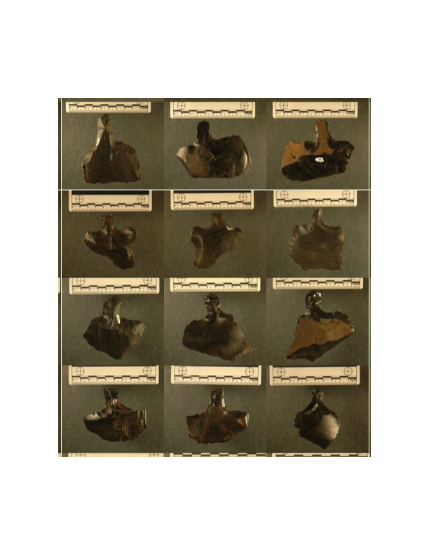

Figure 2. *Mata’a* examples from Rapa Nui.



Figure 3. Locations of *mata’a* collections from Rapa Nui, Chile.

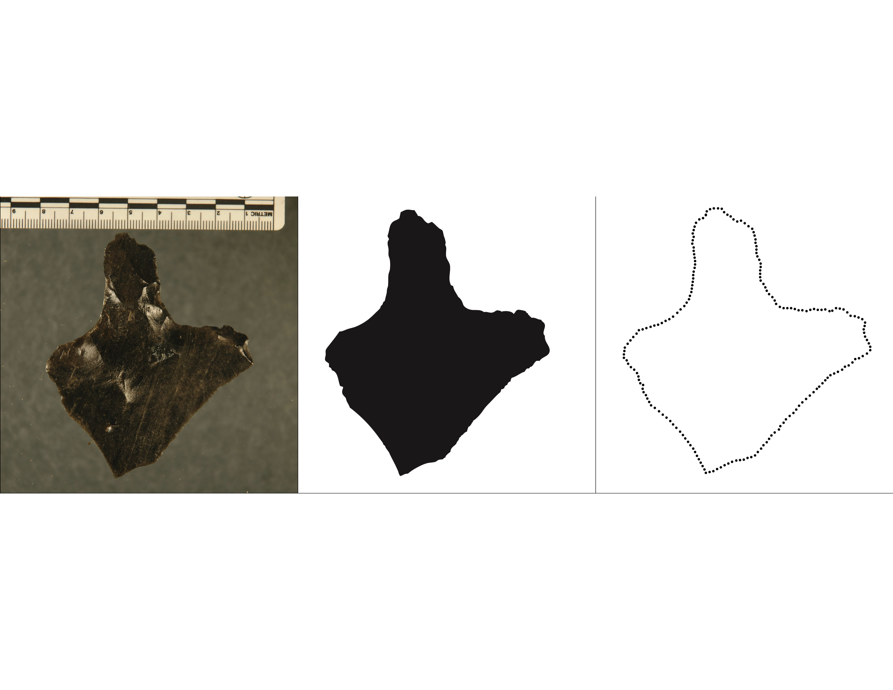

Figure 4. Measurement process used to generate *(x; y)* outline coordinates for each *mata’a* image.

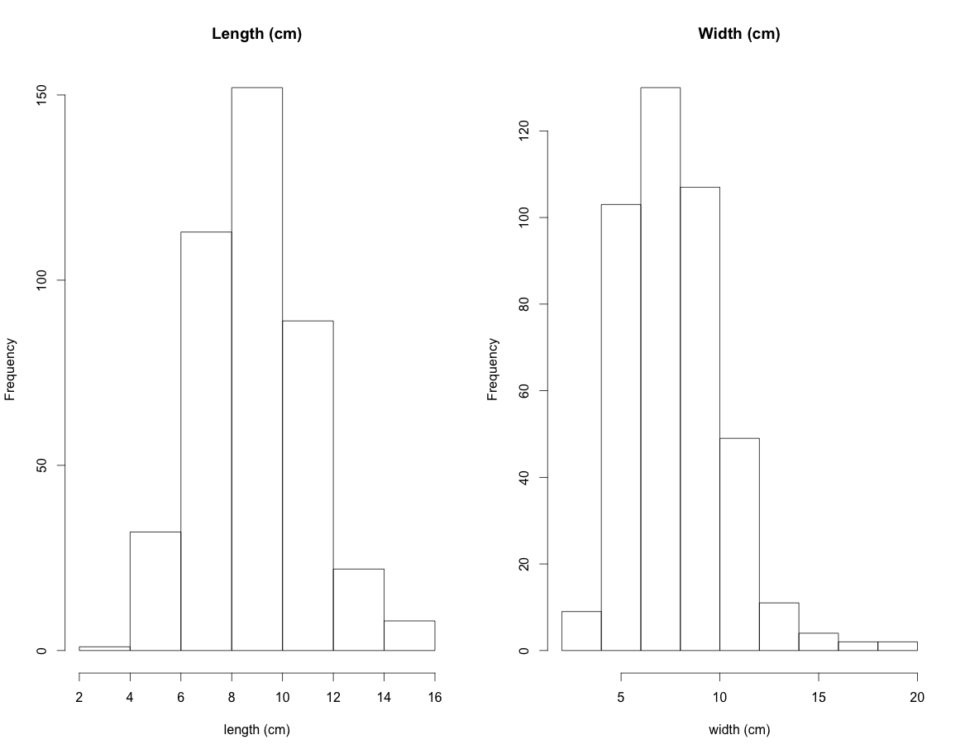

Figure 5. *Mata’a* lengths and widths.

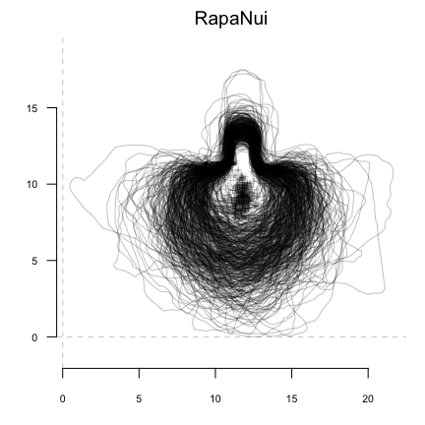

Figure 6. Superimposed *mata’a* outlines from Rapa Nui. For comparison, all *mata’a* are aligned at the center point of the haft where it meets the blade.

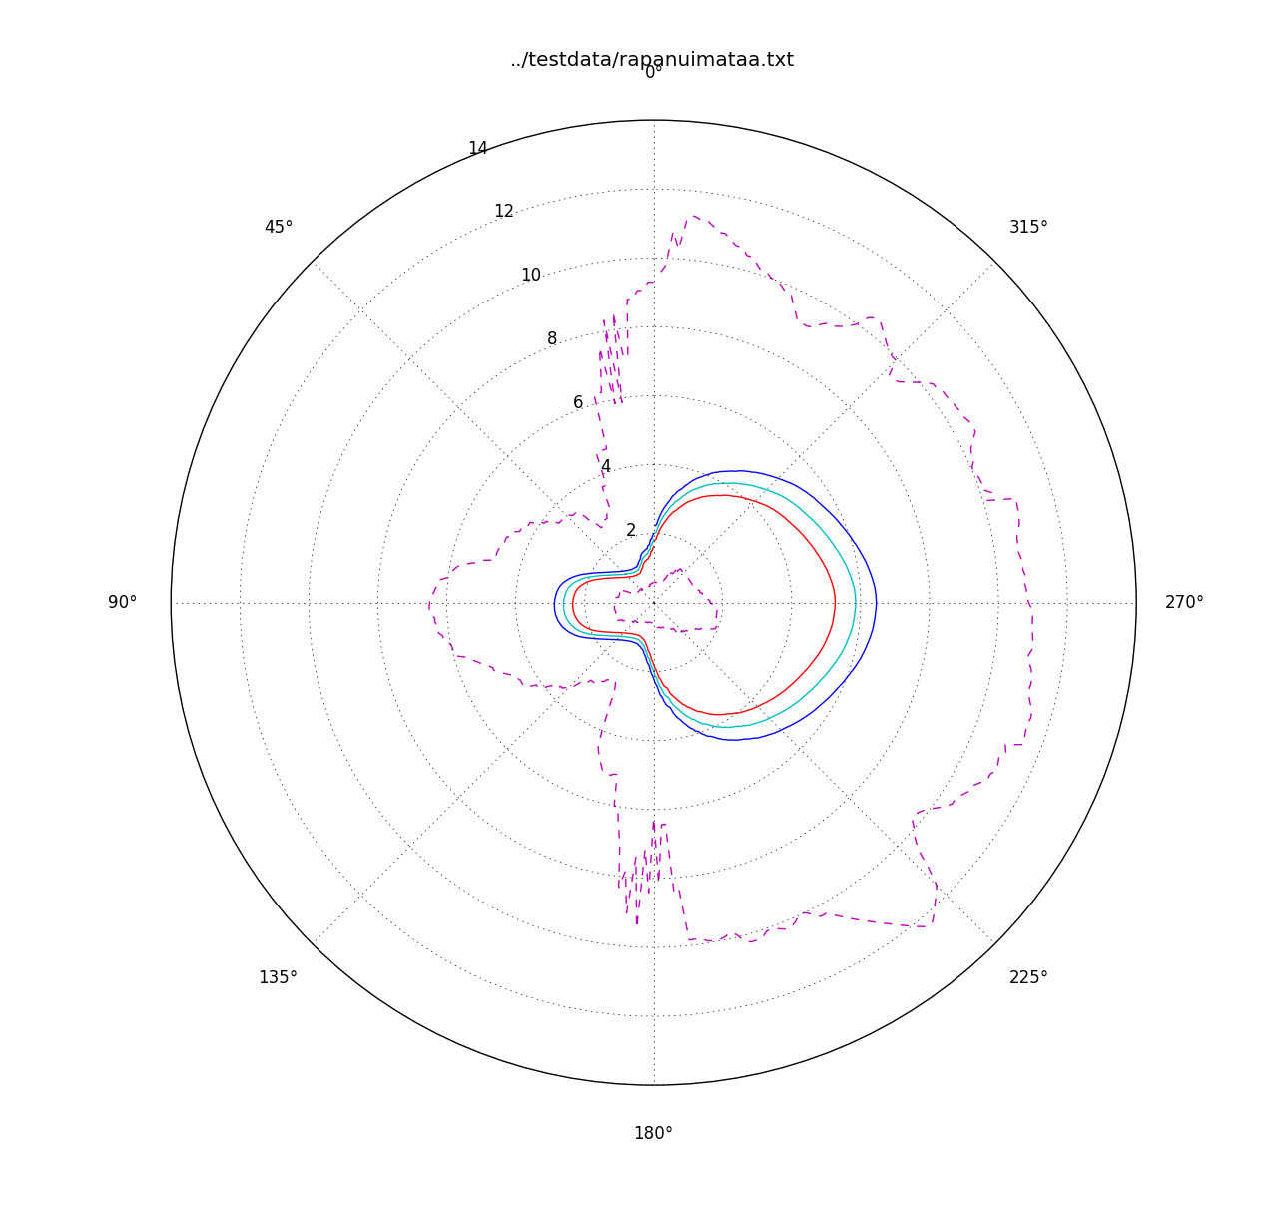

Figure 7. Variability in *mata’a* shape shown with mean and 95% confidence intervals. Note that the 95% confidence intervals are shown with exaggerated differences between the values to illustrate areas with greater variance versus those with more constrained shape. Here, the area at the base of the stem where it meets the blade is the most constrained portion of *mata’a* shape while the stem length and blade are more variable.

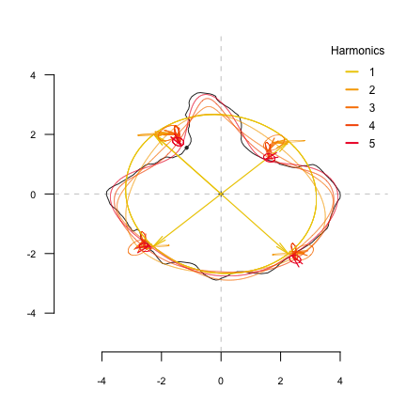

Figure 8. Elliptic Fourier analysis is based on the sum of harmonic trigonometric functions, fitting separately x and y coordinates, that together define ellipses in the plane. Five harmonics are here shown at four locations on the original outline of a *mata’a*. As the number of harmonics is increased the reconstruction better approximates the original shape outline.

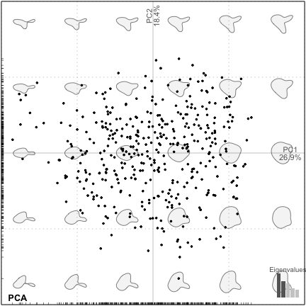

Figure 9. First two principal components (PC1 and PC2 are on the x- and y-axis, respectively) for the Rapa Nui *mata’a*.

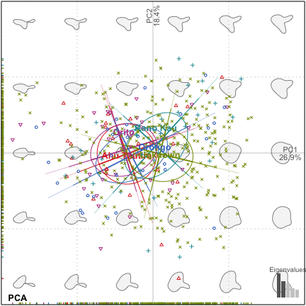

Figure 10. First two principal components of *mata’a* grouped by site location.

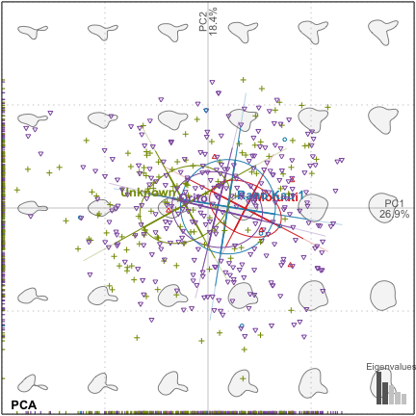

Figure 11. First two principal components of *mata’a* grouped by site location.

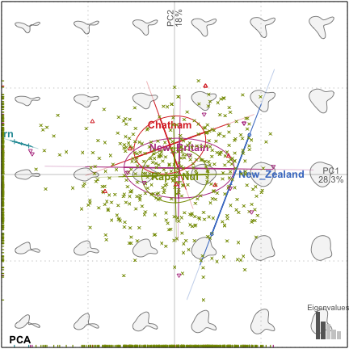

Figure 12: Factorial maps depicting the two principal components (PC1 and PC2 are the x- and y-axis, respectively) of morphological variation for stemmed lithic shaped objects from Rapa Nui, New Britain, New Zealand, Chatham and Pitcairn Islands. The shapes are reconstructed from the factorial map using the first two component axes.

# SUPPLEMENTARY INFORMATION

1*Momocs* builds upon techniques developed by Claude (2008) and reviewed by Bowman (2009). Bonhomme incorporated functions from Claude's work into an integrated framework and a standalone R package. The package's vignette *A* *Graphical Introduction to Momocs and Outline Analysis Using R* (Bonhomme 2012) provides an extensive description of the functions of the package. All of the R code and data for this project is freely available at <https://github.com/clipo/mataaMorphometrics>.

2While our measured outlines are composed of 200 points, *Momocs* interpolates between points to locate distances from centroids at even intervals. In addition, since all measurements are based on georeferenced coordinates, planimetric measure (such as width or length) can be calculated. Additional image analysis techniques to isolate object outlines point to the strong potential for automation of the measurement process, greatly increasing the ability to characterize large assemblages. With large numbers of measures of radial distances made relative to the *mata’a* centroids, we then calculate a statistical summary for each angle to assess variability in relative dimensions.

3In morphometrics, Fourier treats closed outlines as periodic functions. If you start somewhere on the outline and follow it, you will pass again and again by the same starting point and thus periodic functions can describe this outline. These functions can use a variety of descriptive data for the outline: the distance of any point on the outline to the centroid of the shape, the variation of the tangent angle for any point, or the (x/y) position on the plane (Rohlf & Archie 1984). For an outline shape, a periodic function is obtained and can be decomposed (and thus described) by Fourier series.

Fourier series, however, work on continuous functions. Since in practice shape is measured on a finite number of discrete points on a plane (in our case, x/y coordinates), a discrete equivalent to Fourier series is used in morphometrics. A given number of points called pseudo-landmarks have to be sampled along the outline before computing shape analysis. All Fourier decomposition then result in an harmonic sum of trigonometric functions associated with harmonic coefficients. They are (usually) normalized to remove homothetic, translational or rotational differences between shapes. Two or four coefficients, depending on the approach used, are obtained for each calculated harmonic and can then be considered as quantitative variables. The geometrical information contained in the outlines are thus quantified and can be analyzed with classical multivariate tools.

To conduct Fourier analysis, we must estimate the number of necessary harmonics after examining the spectrum of harmonic Fourier power. The power is proportional to the harmonic amplitude and can be considered as a measure of shape information. As the rank of the harmonic increases, the power decreases and adds less and less information. We can evaluate the minimum number of harmonics required to best approximate the shape. In the case of the *mata’a* and using x/y position for points on the outline as the data set, 12 harmonics provide a good reconstruction of the overall shape (Figures S3 and S4).

# References Cited

Bonhomme, V. 2012. *A graphical introduction to Momocs and outline analysis using R.* <http://www.vincentbonhomme.fr/Momocs/vignettes/>.

Bonhomme, V., S. Picq, C. Gaucherel & J. Claude 2014. Momocs: Outline analysis using R. *Journal of Statistical Software* 56: 1–24.

Rohlf, F. & J. Archie 1984. A comparison of Fourier methods for the description of wing shape in mosquitoes (Diptera: Culicidae*). Systematic Biology* 33(3): 302–17.

Table S1: *Mata’a* included in analyses by site and by repository..

|  |  |  |  |  |  |
| --- | --- | --- | --- | --- | --- |
|  | Ahu Tautira | Orito | Orongo | Rano Kau | Unknown |
| Bishop Museum | 0 | 0 | 0 | 0 | 291 |
| Sebastian Englert Museum | 25 | 31 | 29 | 33 | 0 |

Table S2: *Mata’a* included in analyses by obsidian source.

|  |  |  |  |  |  |
| --- | --- | --- | --- | --- | --- |
|  | Ahu Tautira | Orito | Orongo | Rano Kau | Unknown |
| Motu Iti | 0 | 0 | 0 | 0 | 5 |
| Orito | 0 | 0 | 0 | 0 | 279 |
| Rano Kau 1 | 0 | 0 | 0 | 0 | 7 |
| Unknown | 25 | 31 | 29 | 33 | 8 |

Table S3. Stemmed lithic tools from other locations in the Pacific.

|  |  |  |
| --- | --- | --- |
| Island | Number | Source |
| Chatham | 8 | Jones 1981 |
| New Britain | 12 | Torrence 2009a, 2009b, 2013 |
| New Zealand | 2 | Jones 1981 |
| Pitcairn | 2 | Heyerdahl & Ferdon 1965 |

Figure S1. Sample size and *mata'a* parameter estimation. By resampling the collection with an increasing number of samples and comparing changes in the mean of length and width, we can assess the degree to which our estimates change with increasing samples. The sample size (N=417) of *mata'a* appears to be sufficient to estimate variability in the basic shapes.

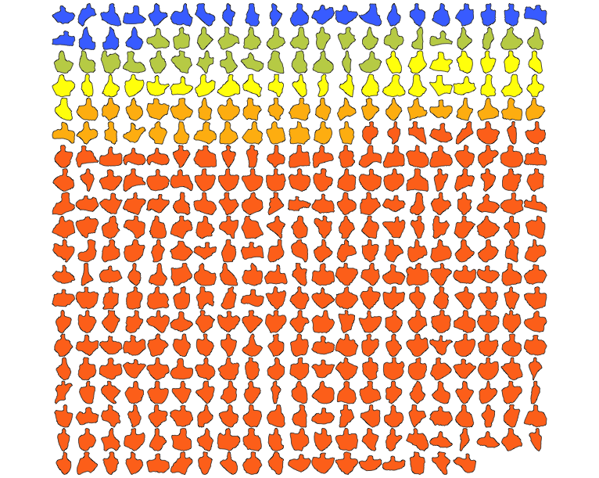

Figure S2. *Mata’a* included in the current analyses. The 5 colors indicate the collection locations on Rapa Nui (Blue=Ahu Tautiri, Green=Orito, Yellow=Orongo, Orange=Rano Kao, Red=Location only known to the level of the island).

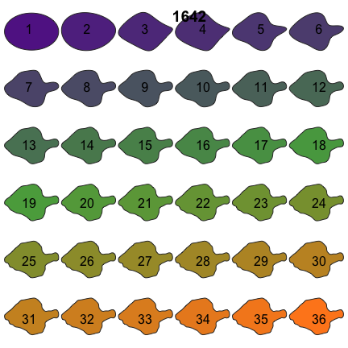

Figure S3. *Mata’a* reconstructed from different numbers of harmonics. Twelve harmonics provide a satisfactory reconstruction.

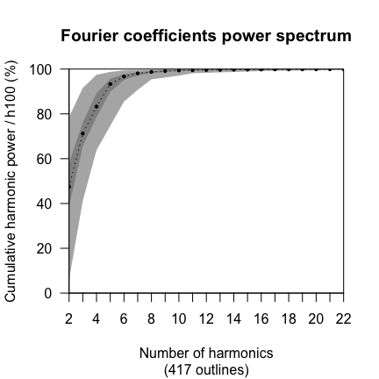

Figure S4. Cumulated harmonic Fourier power calculated from Rapa Nui *mata’a*. The 12 first harmonics gather nearly 100% of the harmonic power. Maxima, minima and medians are also plotted.